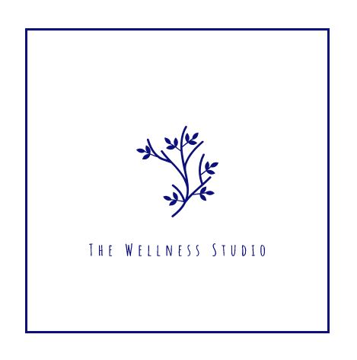
Intro to Essential Oils
Don’t know how to use essential oils or do you feel overwhelmed with the amount of information floating around?
Come experience essential oils hands on during this introduction to essential oils class.
During this class we will cover the basics like how to use essential oils properly and when to use them.

We will also touch on a few of the most popular oils and their uses.
This class is free and open to everyone.

2nd & 4th Monday’s of the month  12:00pm-1:00pm | The Wellness Studio  2647 Milwaukee Street  Madison, WI 53704
Catrice Dowd is a wellness advocate for doTERRA Essential Oils. She joined doTERRA in Oct. 2017 with a passion for helping people achieve their health and wellness goals naturally. She enjoys teaching others how to implement essential oils into their everyday lifestyle and how to remove harmful chemicals from their everyday living.

Check our calendar of events page: www.soarcms.org or email: thewellnestudio@soarcms.org

